Instructions for opening the Vancouver Island SEI Field Inspection Data (mdb)
In order to use the field report generator which is part of this database, users will need to do a bit of file repair first. Note: you may need to repeat this process each time you open the file.
- Double click to open the file. It will look something like this:
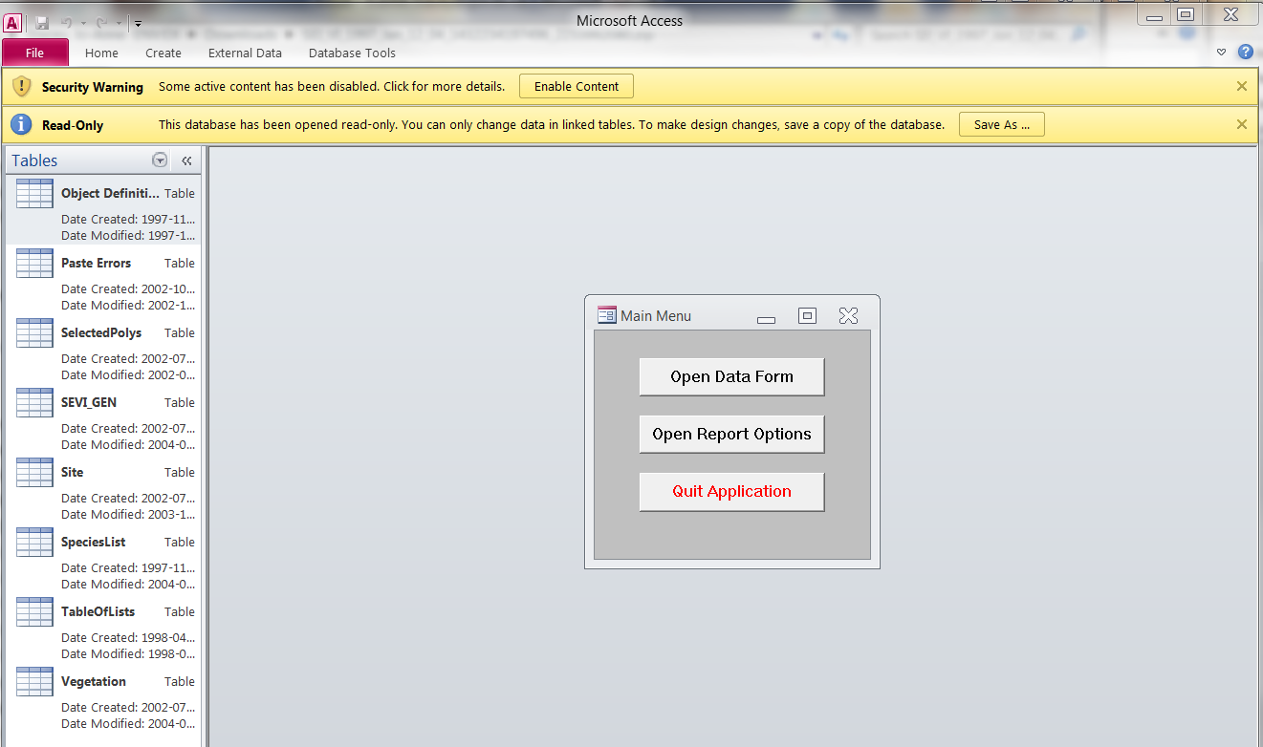
- Enable content in the Security Warning bar at the top of the screen.
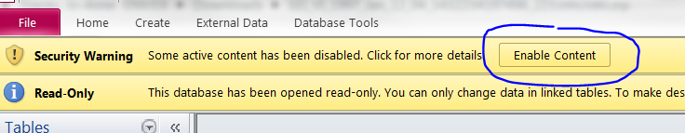
- Right click in the grey space around the Main Menu (see image 1) and then hit ‘Control’ and ‘G’ at the same time on your keyboard. This will open the Visual Basic screen for the application.

- From the banner across the top click the Tools dropdown and select References
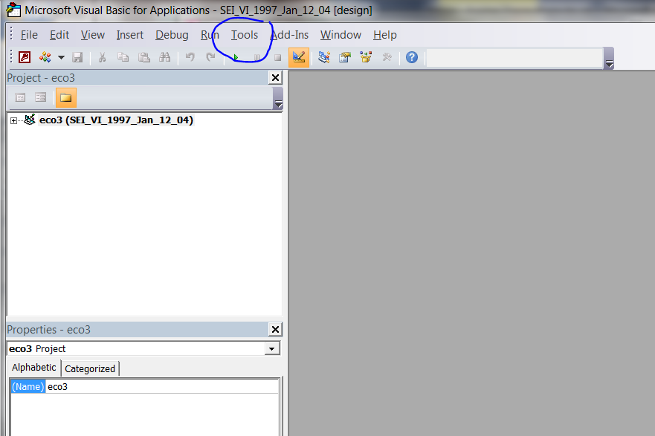
- Click OK to this error message (this is what you are about to fix)
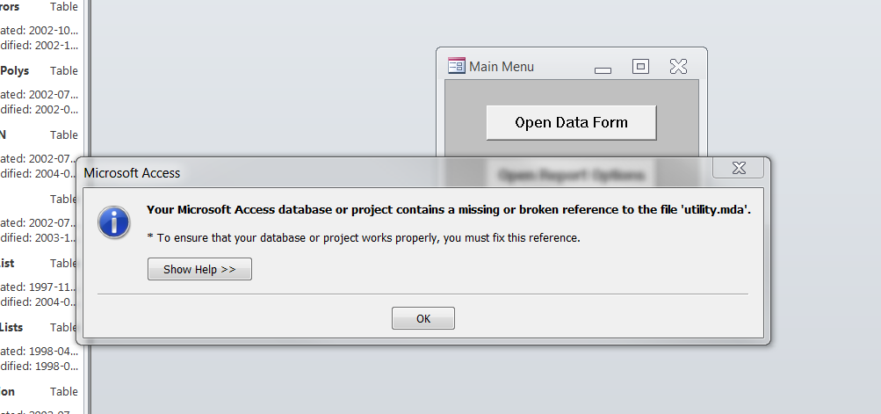
- Uncheck the box beside MISSING: utility.mda. Click OK.
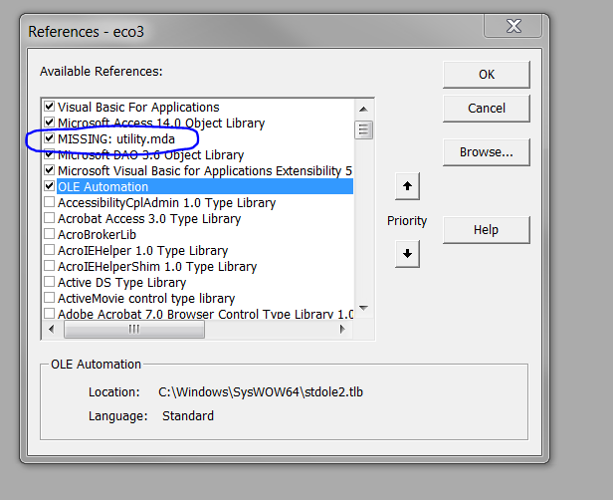
- Open Reports Option and enter the polygon numbers of interest (one on each row) 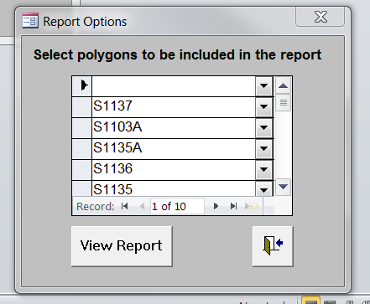

- Click View Report. Use the page indicator at the bottom of the page to scroll through the reports.
